MEB YKS ÇALIŞMA SORULARI CEVAP ANAHTARI
.1. TEST 1 Kader İnancı

CEVAP ANAHTARI
1-B | 2-E | 3-D | 4-D | 5-B | 6-A | 7-D | 8-A | 9-C | 10-E
11-C | 12-B | 13-C | 14-D | 15-C | 16-D | 17-E | 18-E | 19-E | 20-A
21-B | 22-C | 23-C | 24-C | 25-E | 26-D | 27-D | 28-A | 29-C | 30-B
31-C | 32-C | 33-B | 34-D | 35-E | 36-B | 37-C | 38-C | 39-E | 40-A
41-D | 42-A | 43-A | 44-C | 45-C | 46-A | 47-B | 48-C | 49-E | 50-D
51-A | 52-E | 53-D | 54-C | 55-B | 56-E | 57-B | 58-B | 59-A | 60-C

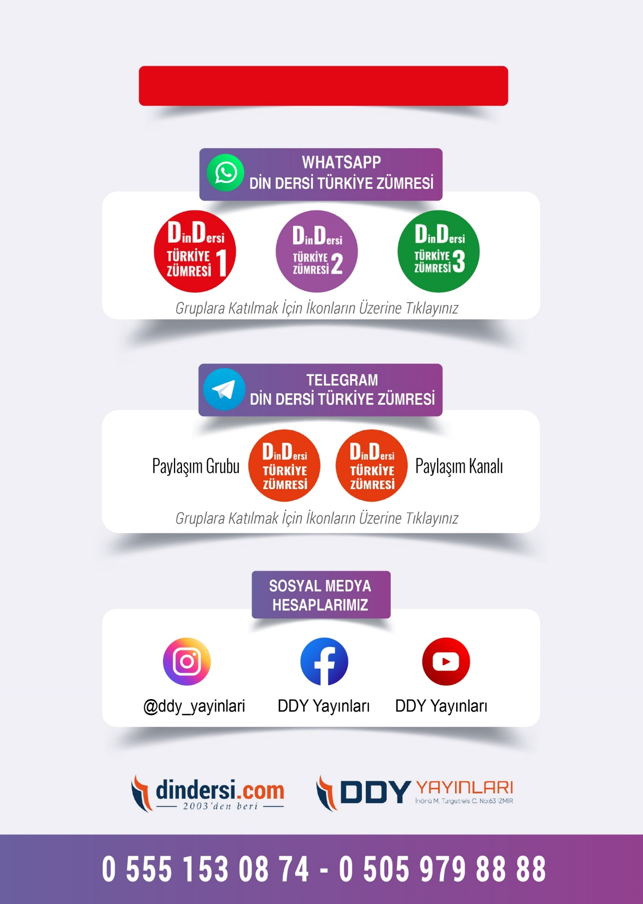
DDY YAYINLARI
LİSE YARDIMCI KAYNAKLARININ PDFLERİNİ
İNCELEMEK İÇİN TIKLAYINIZ.
MEB YKS ÇALIŞMA SORULARI VE CEVAP ANAHTARI İÇİN TIKLAYINIZ.
